Designhack co-design report
Insect AI workshop 9th May 2025, Tirana, Albania

Aim
Within InsectAI we have the ambition to co-design a piece of insect monitoring hardware that uses AI and cameras. This will be a co-designed tool, bringing together people from across the action to share their knowledge. To avoid stepping on anyone's toes, we will be focussing on a tool for engagement and education, something that will inspire the user with the wonder of insects and the power of AI, rather than a research tool.

The aim of the workshop in Albania was to develop a scope for the tool we wish to develop and to brainstorm ideas that could be taken forward.

Background
The workshop started with a short presentation (figure 1) on the background to the project and the timeline for delivery. The workshop was attended by approximately 20 people and consisted of a number of breakout sessions.

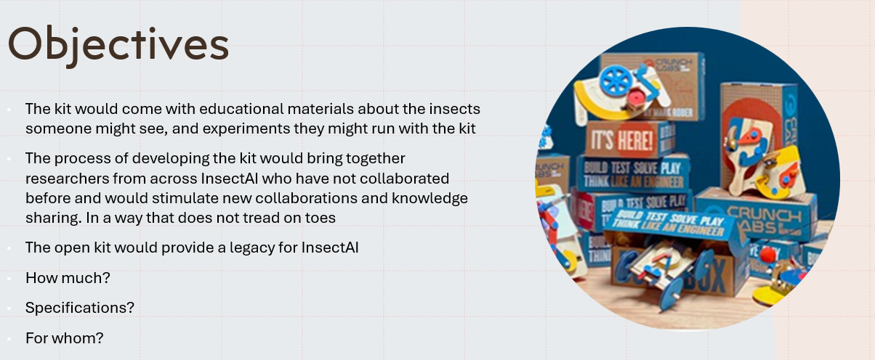
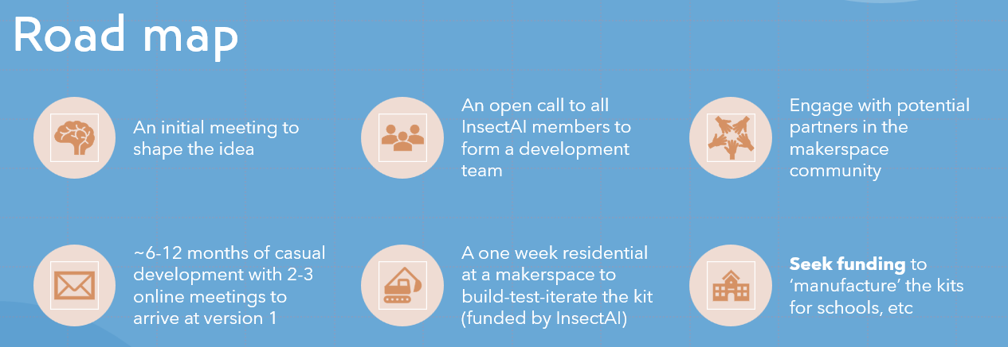
Figure 1 - Key slide elements from the introductory presentation

We first broke out into groups to brainstorm who our audience could be, what we might want the tool to be capable of, what educational materials we might produce with it, and where people might use it (+ where we might be able to run a design hack).

Who could this be for?
- Young people
- Educators/parents to use with young people
- Adults, perhaps with a focus on disabilities groups

What materials should come with it?
- Activity plans: options for focus of experiments, entomology or computation/AI/coding
- Support: Online forum for Q&A, paper guides, online documentation, online videos
- Supplementary materials: Fact sheets and inspiring information about insects, online and provided physically with kits

How should we co-design it?
- People: bring together experts in hardware, AI, children's education, and children themselves
- How: Involve children in design from early on, iterate rapidly, delegate/compartmentalise development
- Where: engage with school groups in schools, run an in-person design-hack for the final push

Groups were then asked to choose a specific audience and develop a project plan for that group. This raised some common themes in addition to those previously identified: 1) the need for an interdisciplinary team 2) the quest to find funding to make this happen 3) building in flexibility in the hardware and educational materials to make it flexible to a number of settings and experiments 4) getting funds to distribute packs at the end of the project.

The next steps will be to form a working group to take all these ideas forward and to start to design the real thing! We will soon send out an email to all members to get interest in joining this group and will welcome anyone with an interest.

